# Bluetooth

Pooja Shah 010828311

Learning objective: Using SiriKit develop Senior Citizen Assistance App. The goal of the App is to understand Senior Citizen Speech and store in the database.

1. **App Design**



Fig 1. App

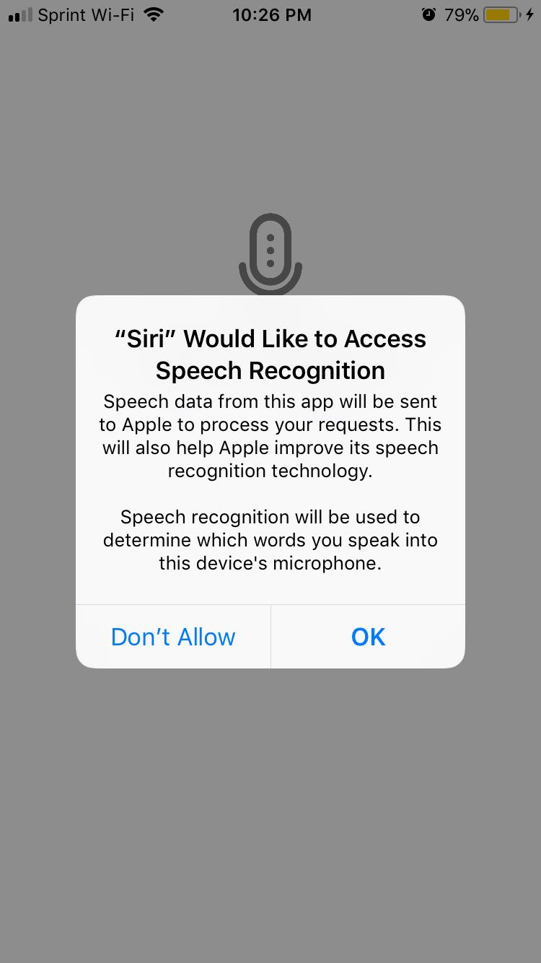

Fig 2. Speech Recognition Permission

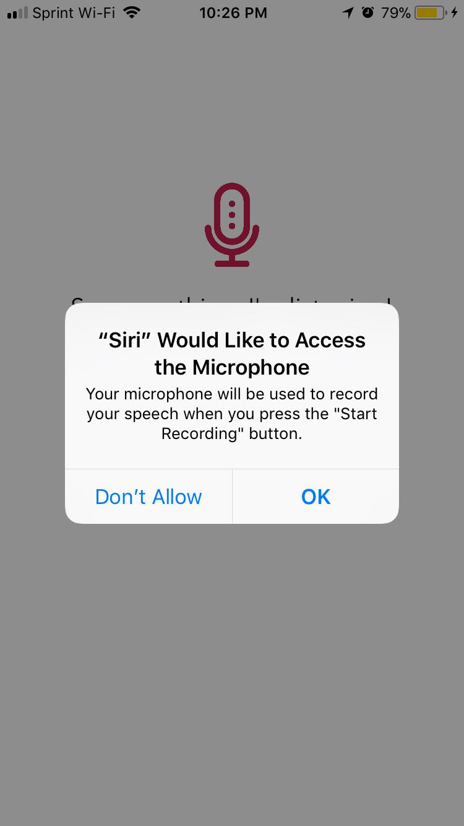

Fig 2. Microphone Access Permission



Fig 3. Siri is ready to listen



Fig 4. Siri captures voice input

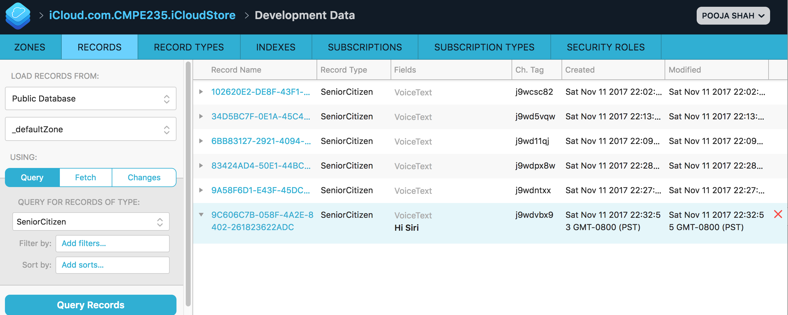

Fig 5. Cloud saves the data